Name ________________________________ AP Calculus
Section 3.6: Chain Rule

Show all your work!

1.

2.

3.

4.

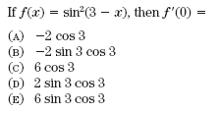
5.

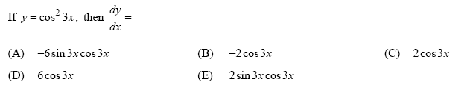
6.

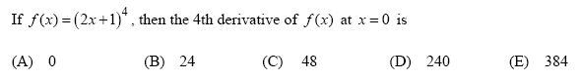
7.

8. 